September 2020
Programme 2020 - 2021
2nd | Opening night drinks and nibbles |  |  |  |  | Members bring images and explain how and why they produced them
9th | Tim Cossings  Guisborough CC |  |  |  |  | A Kenyan Safari.
16th | Dennis Dunning |  |  |  |  | Developing a Personal Approach to Photography
23th | First competition |  |  |  |  | Judge – Trevor Roxby
30th | Recorded Lecture |  |  |  |  | The Art or Black and White
October 2020
7th |  | Mark Banks |  |  |  | Landscape Photography  www.markbanksphotography.com
14th |  | Interclub competition with Hartlepool CC |  |  |  | Hosted by Stockton CC  Judge – Malcolm Boyd
21st |  | 2nd Competition -theme ‘People) |  |  |  | Judge – Dick McReaddie
28th |  | Les Forrester BA Hons Photo, ARPS DPAGB, EFIAP, BPE3* |  |  |  | My Vision of Photography
November 2020
4th |  | Recorded Lecture |  |  |  | The Art of Seeing
11th |  | Practical Night
18th |  | Norton Tankard competition |  |  |  | Judge – David Stout EFIAP, DPAGB
25th |  | IT’s a Knock Out |  |  |  | Members bring 4 prints to be judged by membership
December 2020
2nd |  | NYSDA inter club portfolio
9th |  | David Beadle. ARPS  Saltburn CC |  |  | Inspired by Failure
16th |  | Christmas Party |  |  | Pie and peas/quiz
January 2021
6th | 3rd Competition |  |  |  | Judge – Dave Phillips
13th | Practical Night |  |  |  | Subject to be decided on.
20nd | NYSDA silver salver portfolio
27th | The Art of Black and White Photography |  |  |  | Recorded Lecture from PAGB
February 2021
3rd |  | 4th Competition - theme ‘Creative’ |  |  | Judge – Colin Hugill
10th |  | Richard and Janet Burdon |  |  | Greenland Icebergs
17th |  | Club AV Night |  |  | Members bring in their own presentations.
24th |  | NCPF Portfolio
March 2021
3rd |  |  | 5th Competition |  | Judge – Dave Murrell
10th |  |  | Software night
17th |  |  | David and Sheila Coates |  | Roaming About
24th |  |  | Richard Speirs |  | An Evening with Richard Speirs
31st |  |  | Image of the year Competition |  | Judge – Keith Collins
April 2021
7th | AGM
14th | Annual Dinner |  |  | Venue to be confirmed
Competition details
 |  | Date for Entries |  |  | Judging Date
1st Competition
 |  | 2/09/2020 |  |  | 23/09/2020
Interclub Competition
 |  | 23/9/2020 |  |  | 14/10/2020
2nd Competition – theme ‘People’
 |  | 30/9/2020 |  |  | 21/10/2020
Norton Tankard
 |  | 28/10/2020 |  |  | 18/11/2020
3rd Competition
 |  | 2/12/2020 |  |  | 6/01/2021
4th Competition – theme ‘Creative’
 |  | 13/01/2021 |  |  | 3/02/2021
5th Competition
 |  | 10/02/2021 |  |  | 3/03/2021
Print and Digital Image of the Year
 |  | 10/03/2021 |  |  | 31/3/2021
Hand in date for: NYSDPA Competition TBA
NCPF Competition TBA
Meetings are held between 7.30 and 9.30 at:
Room 3
Elmwood Community Centre
53 Darlington Road
Hartburn
Stockton-on-Tees
TS18 5EP

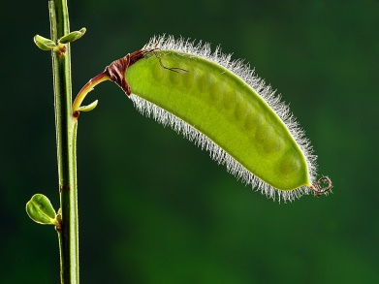
For more details call Steve Smith on 01642 588604 or email on s.smith440@ntlworld.com
Joyce Scott – Digital Image of the year 2019 -2020

Club Officers
Life Vice President | Bill Hopper
Chair | Steve Smith LRPS
Vice Chair | Vacancy
Secretary | Sue Tyerman LRPS
Treasurer | Sue Tyerman LRPS
Competition Secretary | Brian Swales LRPS
Programme Secretary | Steve Smith LRPS
Publicity Officer
Committee Members | Ken Messham
 | Vacancy
 | Vacancy
Ladder Competition Secretary | John Buxton
Projectionist | Ken Messham
Deputy Projectionist | Robert Thomas
NCPF Representative | Mike Vasey
NYSDPA Representative | Andy Gunn
Webmaster | Brian Swales LRPS
Webmaster | Sue Tyerman LRPS
To contact the club:
Call Steve Smith on 01642 588604
Email s.smith440@ntlworld.com
Stockton
Camera
Club

Programme
2020 -2021
www.stockton cameraclub.co.uk
Welcome to Stockton Camera Club
If you enjoy photography – whether taking photographs or simply looking at them, why not come along to our Club?
We have people of all levels of expertise as members, both experienced and novice photographers. No matter what your favourite subject matter or the equipment you use, be it medium format or compact camera, film or digital, if you enjoy taking or looking at photographs, or want to become more proficient at taking them, you will find something to interest you.
We have a full and varied programme of meetings throughout the year including illustrated talks by leading photographers and competitions where independent judges give advice on our efforts.
Members are encouraged to show their images and to demonstrate new techniques or share problems encountered when trying to enhance those ‘difficult’ images. Many of our more experienced members give help on the various methods of enhancing images by digital means.
The club members welcome everyone who comes along. The centre is open from 7.15 with a 7.30 start. The sessions finish at 9.30 with a ten minute tea break. We look forward to meeting you.
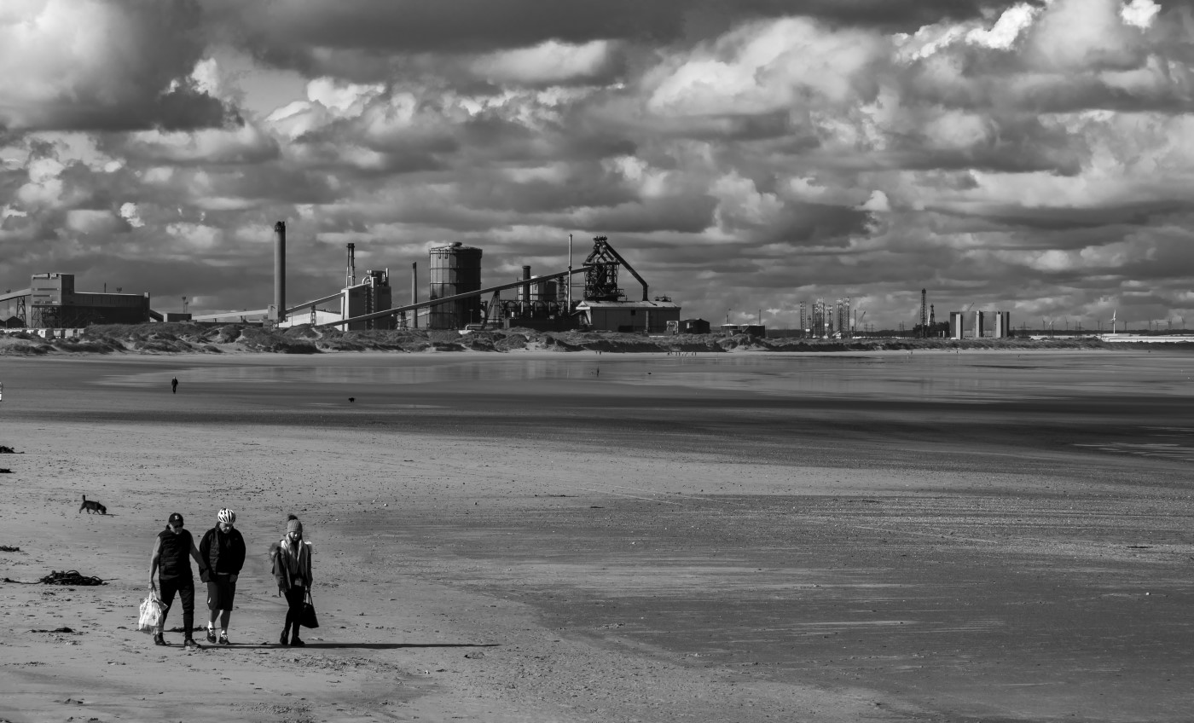

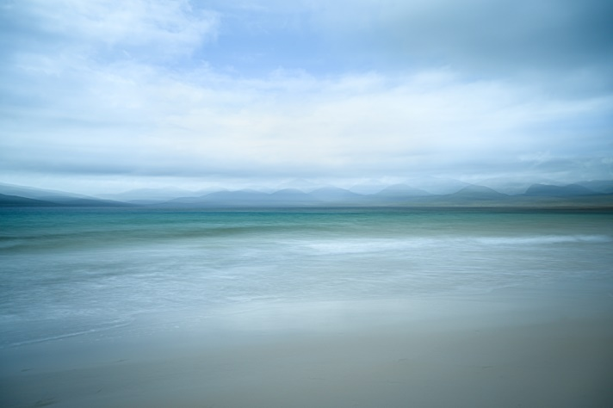
Tom Kirby - Monochrome Print of the Year 2019-2020
Carmel Morris – Colour Print of the year 2019 -2020

Subscriptions

Ordinary Member £48.00
Member and Partner £60.00
Senior Citizen £35.00
Junior and Job Seekers Allowance £26.00

The above subscriptions are inclusive of membership of the NCPF and NYSDPA

